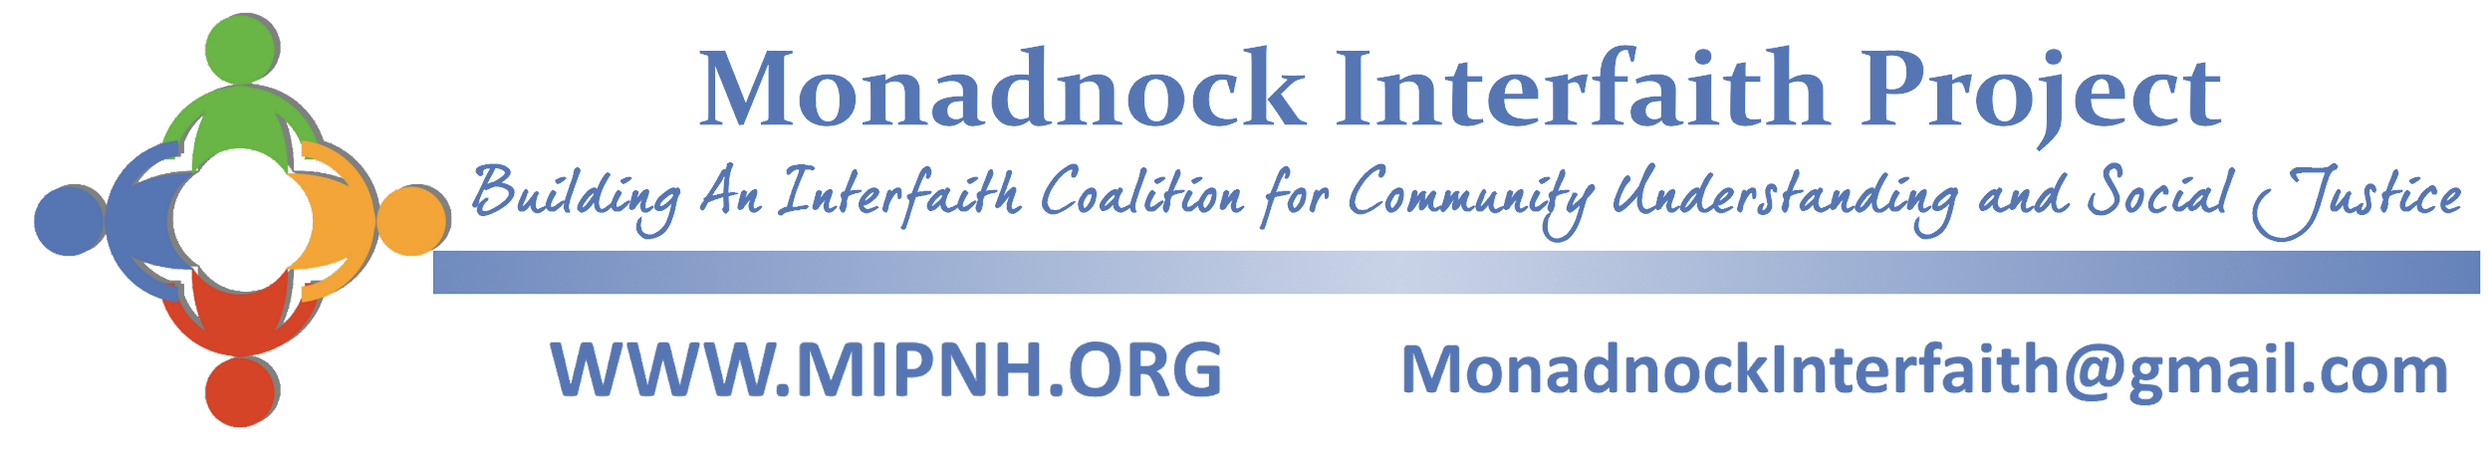

**Congregational/Organizational Partnership with MIP**

Monadnock Interfaith Project (MIP) is a non-profit coalition of congregations, organizations, and wholehearted individuals working together to foster interfaith community, understanding, and systemic change that benefits the region.

Through MIP, we come together to put faith into action.

| **BENEFITS OF PARTNERSHIP** |
| --- |

**Build beloved interfaith community across congregations and differences**

Through coming together we learn about other perspectives, build relationships across congregations and create more unity throughout the community.

**Live our faith traditions’ call for social justice**

Each of our faith traditions call us to justice, healing and loving our neighbor. Through coming together we have the collective power to live out this call for justice.

**Relationships and support for clergy and lay leaders**

Community organizing is deeply relational. Through listening and story sharing, we deepen relationships. Through MIP, clergy and lay leaders meet together for support and collaboration towards interfaith and social justice activities.

**Gain community organizing skills that address challenges faced by many of our congregation and community members**

Many of us face significant challenges and hardships. MIP is a vehicle to share these stories and to work concretely for change and greater opportunity. MIP offers trainings, providing community organizing resources and support.

**Be action leaders for systemic change**

Through MIP, we come together to have collective power to do justice, and win concrete changes in our community.

**Together we can put our faith in action.**

| **BY PARTNERING WE ASPIRE TO…** |
| --- |

**Covenant in good faith**

Partners in MIP agree to uphold the values of relational safety, respect, curiosity, and gratitude. We commit to supporting each other as learners and as people of diverse beliefs. We seek to grow together in love and to act for the greater good.

**Identify coordinators**

Coordinators are a communication link to MIP and coordinate the institution’s participation in MIP community organizing activities, living our faith's call for justice. Congregations and organizations may develop a list of people who are committed to come out in key moments.

**Appoint a representative to the MIP Guiding Council**

MIP’s governing board meets every other month and is composed of institutional representatives and founding councilors. This body provides oversight and makes major decisions of the organization.

| **Contribute annual financial contribution**  A partnership goal is half a percent of the institution’s budget, or more, to help with the vision of MIP being a vibrant, sustainable interfaith community action organization. For organizations who would like to discuss  an alternative contributing amount, please reach out to MIP. | Budget | .25% | **.5%** |
| --- | --- | --- | --- |
| $500,000  $300,000  $150,000  $100,000  $50,000 | $1250  $750  $375  $250  $125 | **$2500**  **$1500**  **$750**  **$500**  **$250** |

| **YES! WE WANT TO PARTNER WITH MIP.** |
| --- |

Institution Name _____________________________________________________________________________________

Contributing Amount ________________________________________________________________________________

Clergy or Board Chair Name ________________________________________________________________________

Signature _________________________________________________________________ Date ______________________

**Our Representative to the MIP Guiding Council will be:**

Name: _________________________________________________________________________________________________

Address: ______________________________________________________________________________________________

Phone: ________________________________________________________________________________________________

Email: ________________________________________________________________________________________________

MIP is an independent, insured, registered NH non-profit organization.

Monadnock Interfaith Project PO Box 161 Keene, NH 03431