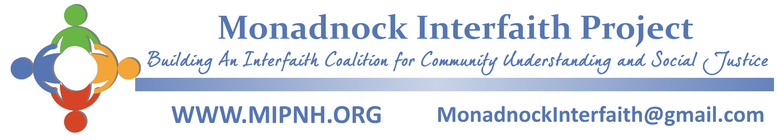

**Individual Membership**

Monadnock Interfaith Project (MIP) is a non-profit coalition of congregations, organizations, and individuals working together to foster interfaith community, understanding, and systemic change that benefits the Monadnock region. Through MIP, people in the region come together to put faith and values in action.

| **BENEFITS OF MEMBERSHIP** |
| --- |

**Experience beloved community**

MIP embraces a culture in which we deepen relationships with others through respectful sharing, listening, and collaborating.

**Expand understanding**

We regularly come together to learn about others’ perspectives, foster relationships across spiritual beliefs, and foster unity across race, class, ethnicity, and faith differences.

**Live a moral commitment to social justice**

Whether we follow a faith tradition or consider ourselves spiritual, but not religious, we seek to treat and care for our neighbors as we, and they, wish to be treated and cared for.

**Build leadership skills**

MIP provides training, resources, and support for developing interfaith community organizing skills.

**Express our deeply held values**

We put our values into concrete action through community organizing. MIP is a catalyst for positive change.

**Take action for systemic change**

By joining together with others, collective power is built to make positive change in our community. Together we accomplish more than any of us can when acting individually.

**Together we can make positive change in our region.**

**We hope you will join us!**

| **BY JOINING MIP, I ASPIRE TO…** |
| --- |

**Engage as an open hearted member**

Participate in a respectful culture of listening, sharing, learning, and collaborating.

**Be involved with interfaith activity**

Engage with others through MIP community events and social justice campaigns.

**Donate annually**

Sustaining a vibrant, active, interfaith community organization requires financial support. Our suggested annual membership is $75. We accept and welcome whatever you can contribute. Donations can be made at any time of the year.

**Bring others along in key moments**

Engage friends and family who share our values in key moments as together we seek to build a powerful network of people across the region working for positive change,

**Participate in collective decision-making**

Join an MIP committee. Vote for representatives on the Guiding Council board. Take part in MIP’s annual meeting and other key gatherings throughout the year.

**Yes! I want to join with MIP to build community, understanding, and social justice.**

Name __________________________________________________________________________

Address ________________________________________________________________________

Phone _________________________________________________________________________

Email __________________________________________________________________________

Skills to offer ____________________________________________________________________

Affiliations, if any ________________________________________________________

| **ANNUAL MEMBERSHIP DONATION** |
| --- |

Yes, I want to be a part of MIP building a vibrant, sustainable organization. I am making the following membership donation:

ロ$5 ロ$25 ロ$50 ロ$75 Basic Membership ロ$125 ロ$250 ロ$500 ロOther $_____

Please make checks payable to Monadnock Interfaith Project and send this form to:

MIP, PO Box 161, Keene, NH 03431 or donate online at [mipnh.org/donate-2/](https://mipnh.org/donate-2/). Thank you!

Signature _________________________________________ Date ______________________

MIP is a non-profit organization. All contributions are tax deductible to the fullest extent of the law.